**ASSIGNMENT #3 MGS 614**

**Problem Statement:** Create a National Comedy Center project in Azure DevOps and add the user stories, acceptance criteria and work items.

We have created a project on Azure DevOps named “NATIONAL COMEDY CENTER”. The project has 4 technical/management members:

* Prateek Madnani: Software Engineer with expertise in full stack development.
* Alankrita Singh: Test Automation Engineer, also skilled in UI Design.
* Prashant Anand: Database Administrator, also skilled in automation.
* Divesh Harchandani- Data Analyst, skilled in marketing analytics.

The project will be spread over 3 sprints, one sprint spreads over two weeks. Below is the project summary with the members involved in the NCC project.

**Our Team:**

|  |  |
| --- | --- |
| **Prashant Anand**     | Prashant Anand is a graduate student in Management Information Systems at the University at Buffalo. Previously, Prashant worked as an analyst at various companies where he improved database frameworks, analyzed data with SQL and Excel, and developed strategies that optimized business operations. Prashant holds a Bachelor of Technology in Electrical and Electronics Engineering. He enjoys swimming, running, and traveling. |
| **Alankrita Singh**     | Before coming to the United States, Alankrita worked as an Application Engineer in India for the past 2 years. She intends to change her career path to data analytics and security as these topics interest her. She completed her BTech in Electrical & Electronics Engineering in 2022 and is now pursuing an MS in MIS to transition into the career track she has chosen. She has worked on various technologies including SQL, JavaScript, HTML/CSS, Java. She is passionate about learning new things, adaptable and driven to excel. |
| **Prateek Madnani**     | Prateek Madnani comes from India with a professional background in Software Engineering. Prateek completed his undergraduate degree in Information Science and Engineering in 2020 and has been working in the software domain since then. He has four years of experience in India on multiple technologies with the focus on backend development. Prateek is currently pursuing his Master of Science in Management Information Systems at the University at Buffalo. Prateek is passionate about technology, is an avid learner and explorer. Prateek intends to work in the field of technical product management after completing his graduate program, so that he can leverage his technical skills from his experience and grow into leadership positions. |

|  |  |
| --- | --- |
| **Project Plan** | |
| Assignment Name | User Stories |
| Assignment  Objective 1 | We need to write User Stories and at least three acceptance criteria for each of the following roles and scenarios:   1. User selecting their favorite comedians 2. Five users interacting with the “Stand-Up Lounge”. 3. User interacting with the final application before they leave the NCC that summarizes their visit. 4. Marketing director generating a report that summarizes attendance figures for the past week. 5. Marketing director determining the four most popular exhibits. 6. Marketing director sending a fund-raising email to all visitors from last week. 7. System administrator verifying the status of all the servers at the start of the day. 8. Database administrator backing up the comedian’s database. 9. Human resources director adding a new cashier to the system. 10. Human resources administrator discharging an employee for a fire able offense. |
| Assignment  Objective 2 | 1. After writing the user stories, we need to determine what tasks will need to get done by developers/programmers/designers to be able to develop a certain feature or functionality to serve that need. You need at least three tasks for each user story. 2. We are going select “create a task” on Azure DevOps to document these tasks and connect them to the relevant user story which the task for your team is derived from. | |

At the first step, we have created the National Comedy Center project on Azure DevOps.

We have created a total of 10 User Stories and 3 acceptance criteria for each user story. There are a total of 3-4 tasks for each user story and the tasks are assigned to respective users according to their skillset.

1. User selecting their favorite comedians.

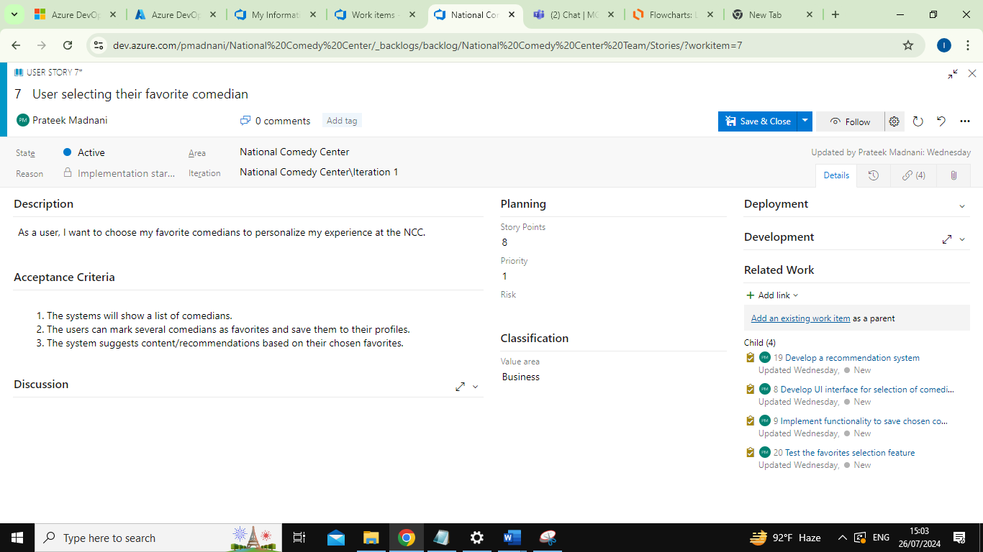

Tasks for User Story 1:

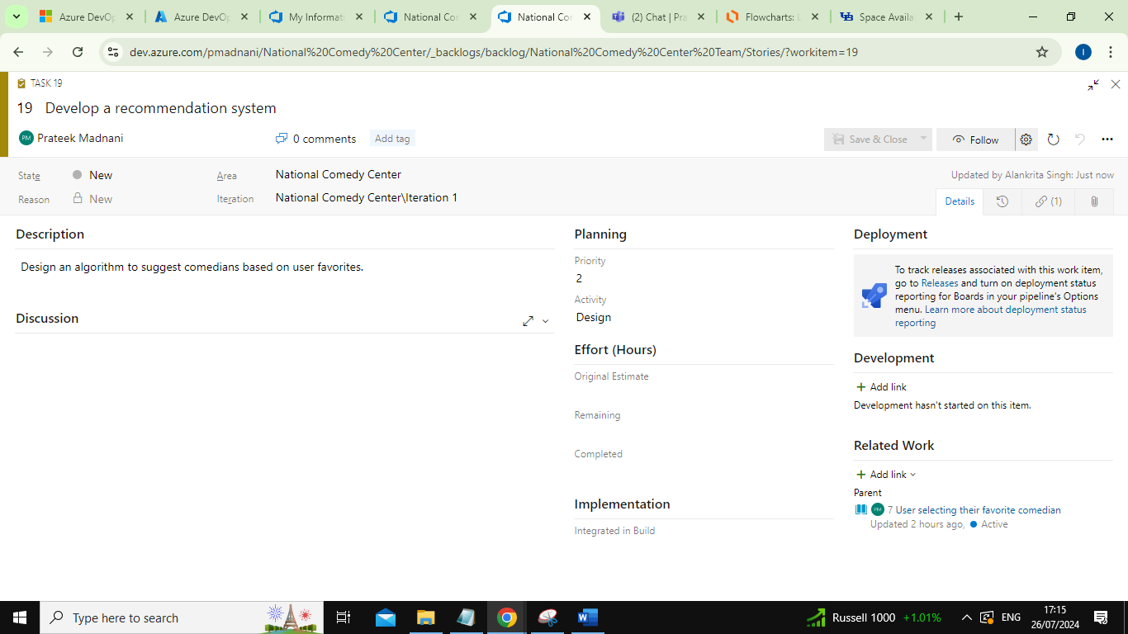

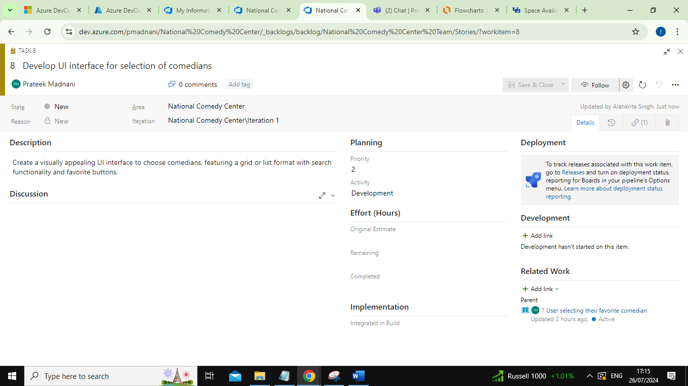

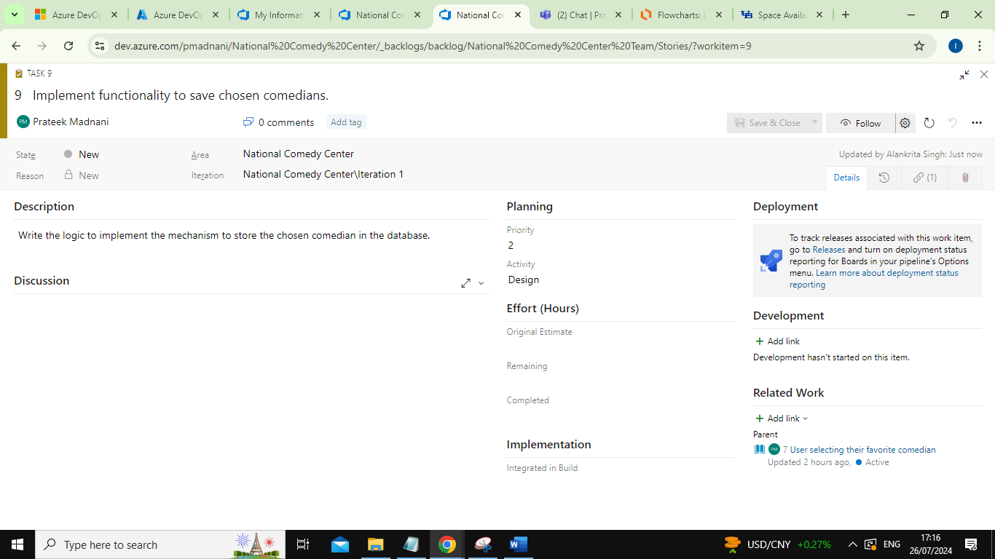

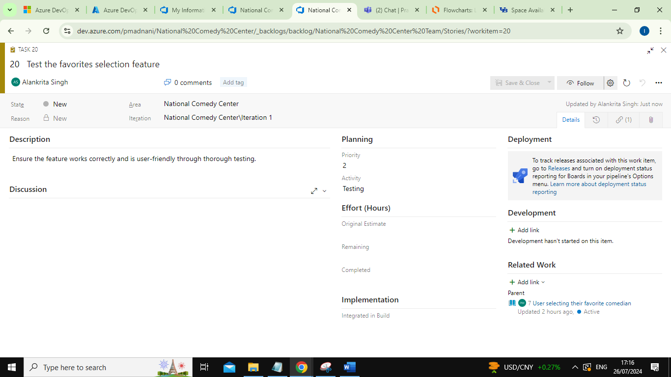

1. Five users interacting with the “Stand-Up Lounge”.

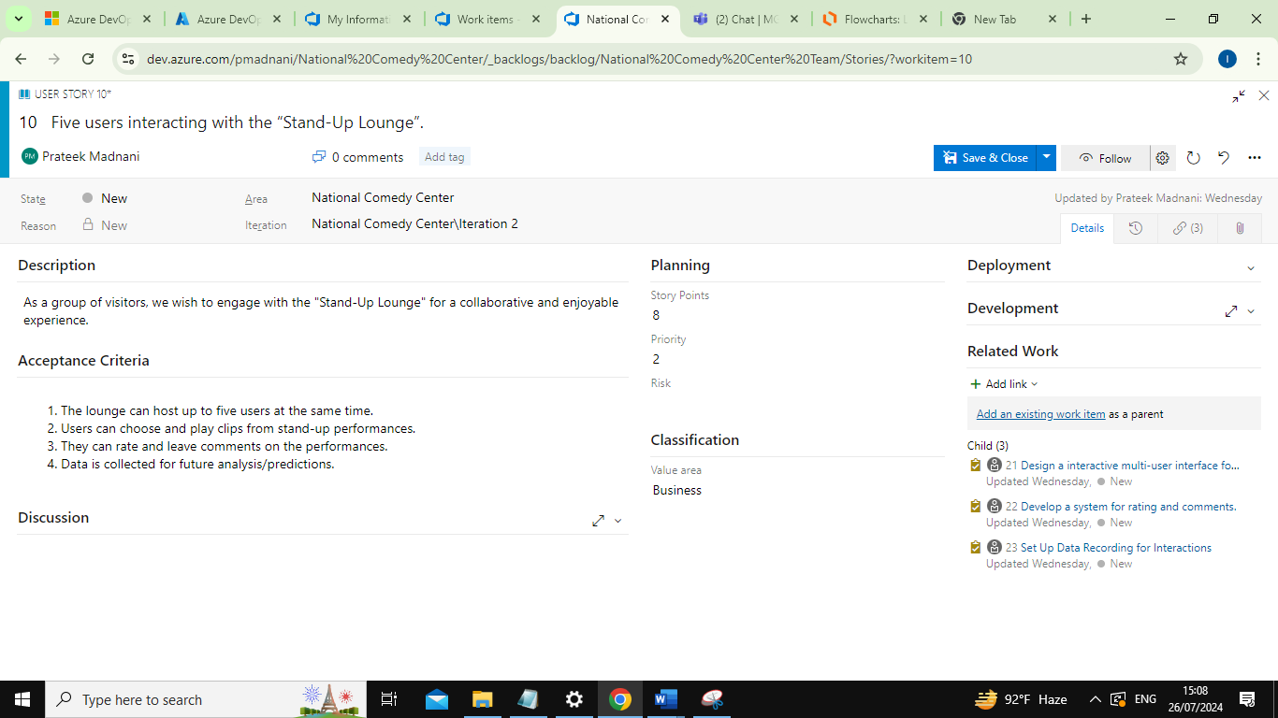

Tasks for User Story 2:

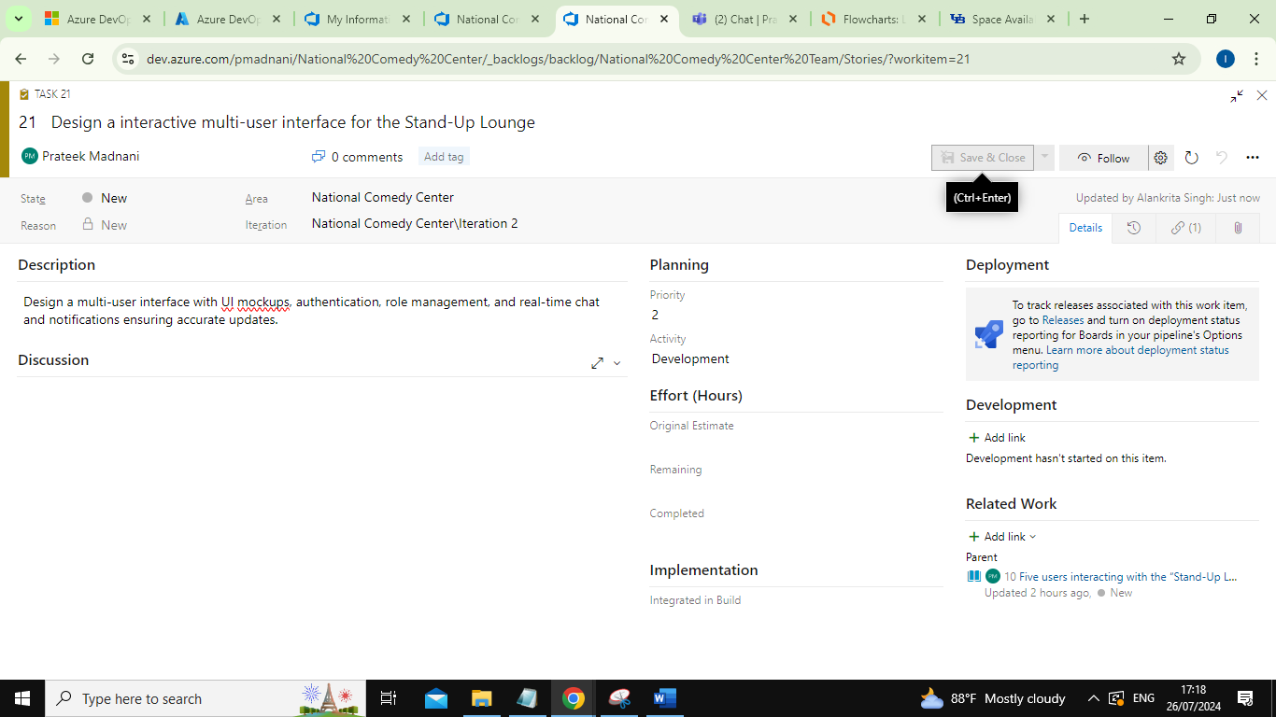

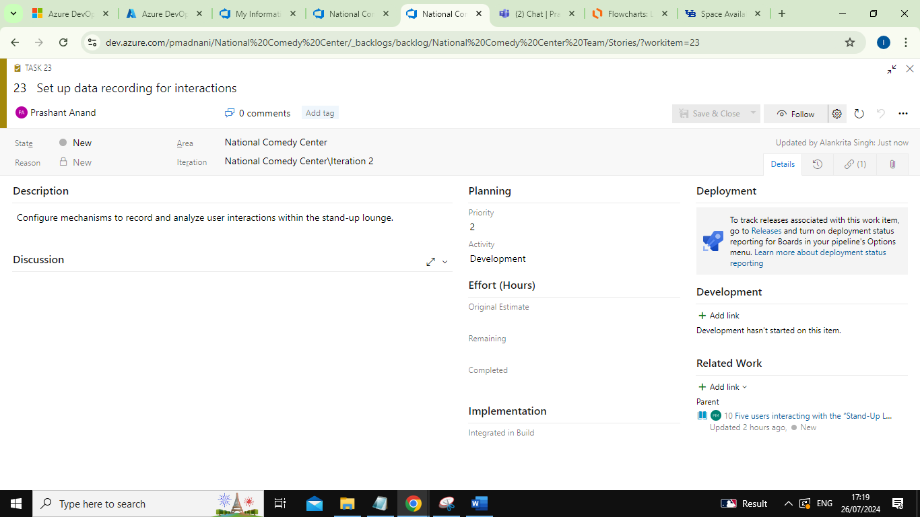

1. User interacting with the final application before they leave the NCC that summarizes their visit.

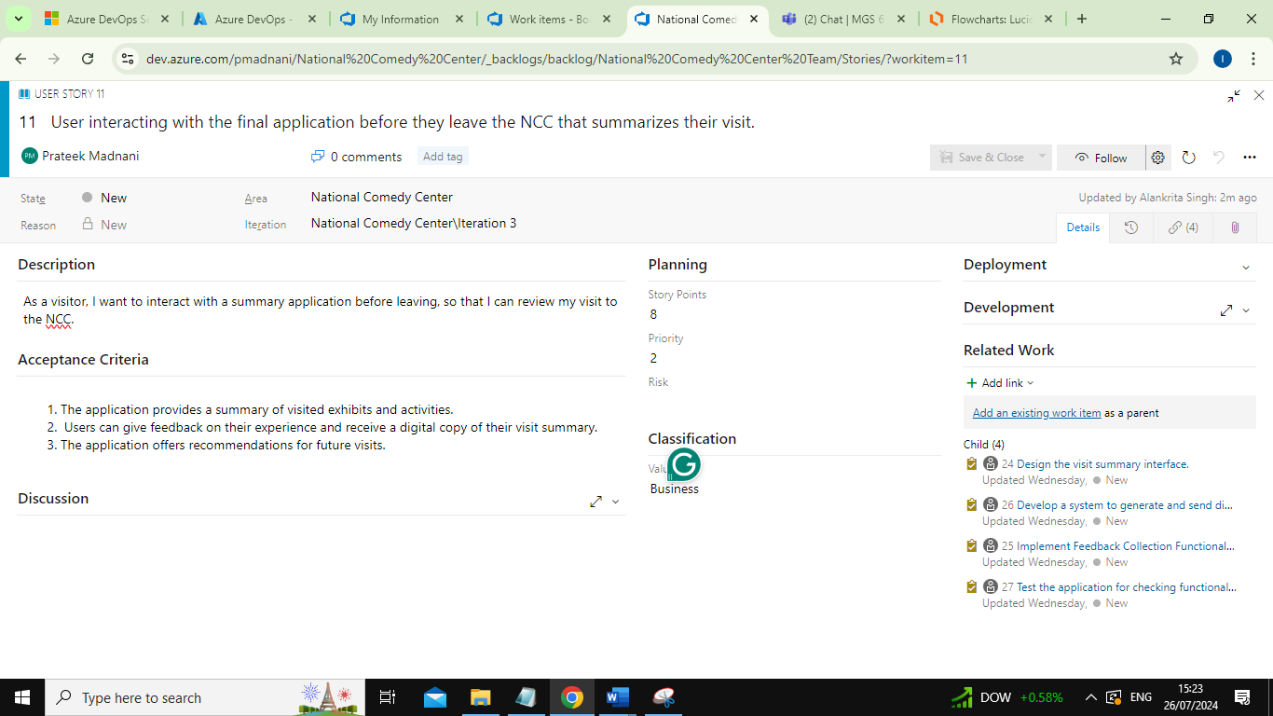

Tasks for User Story 3:

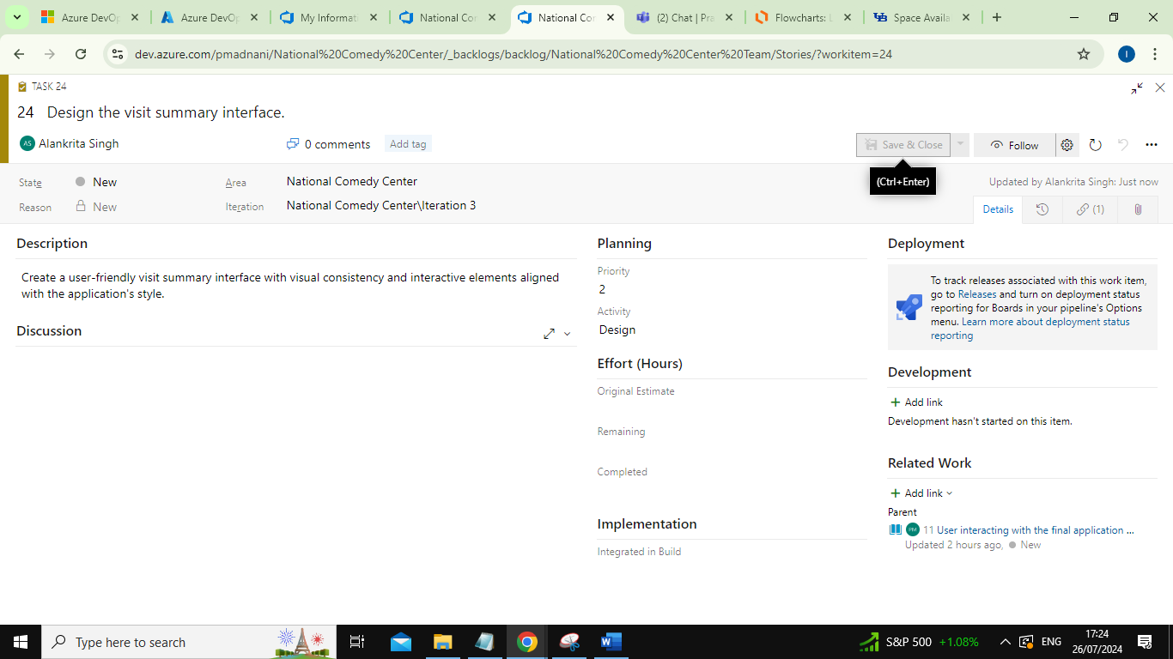

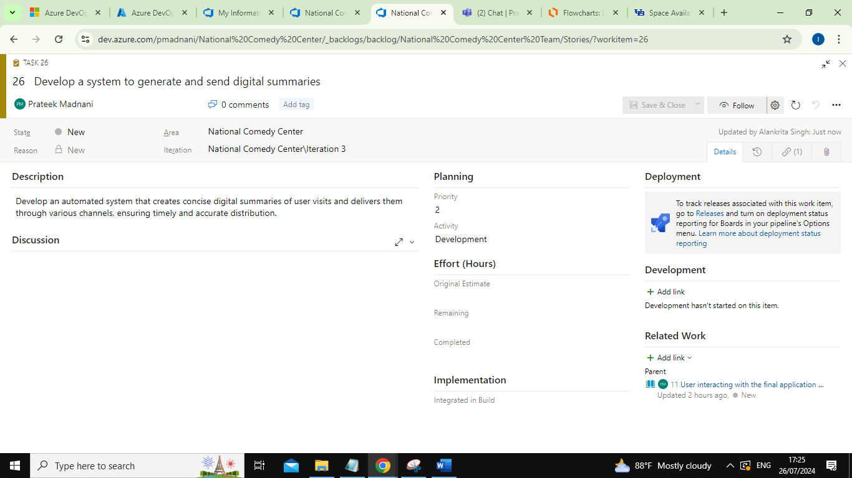

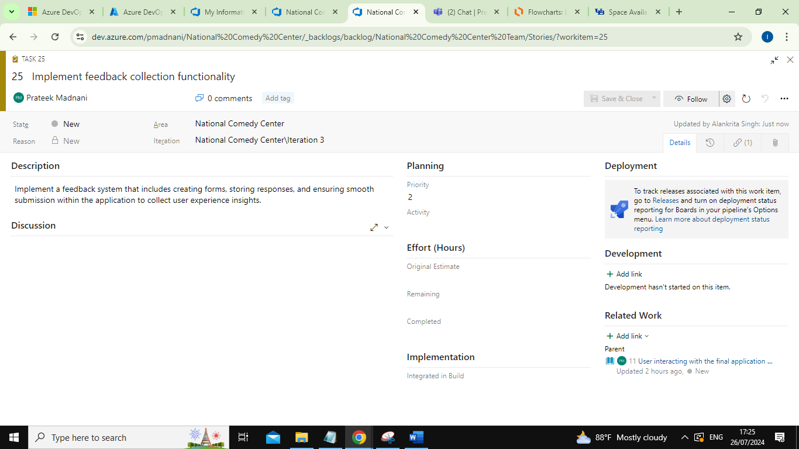

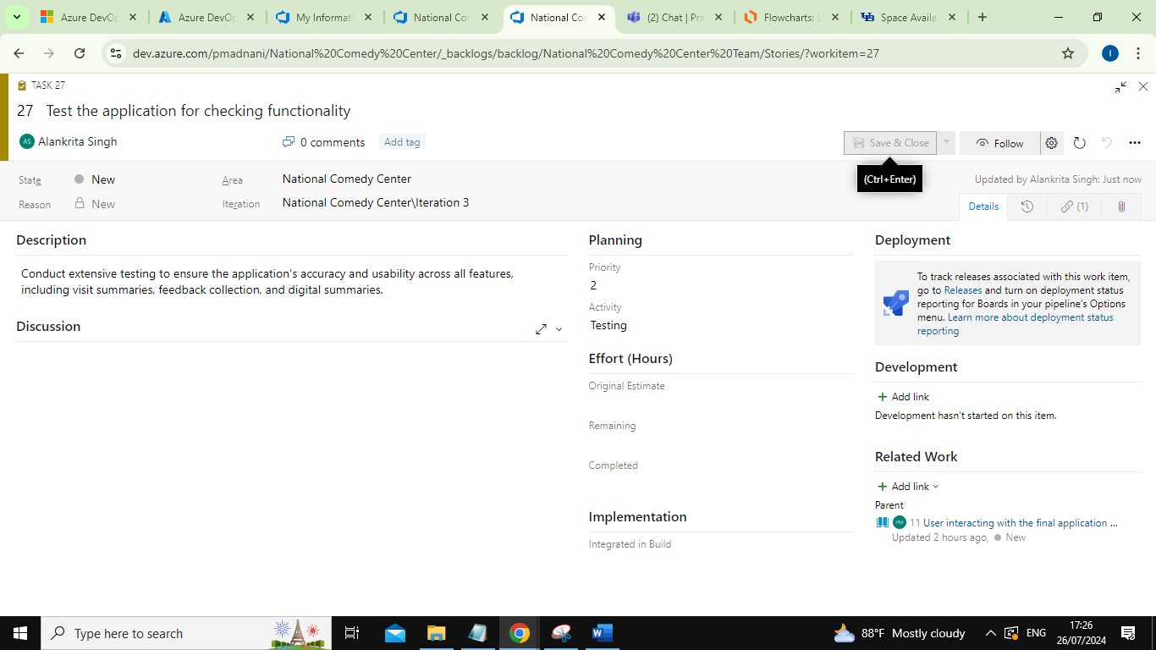

1. Marketing director generating a report that summarizes attendance figures for the past week.

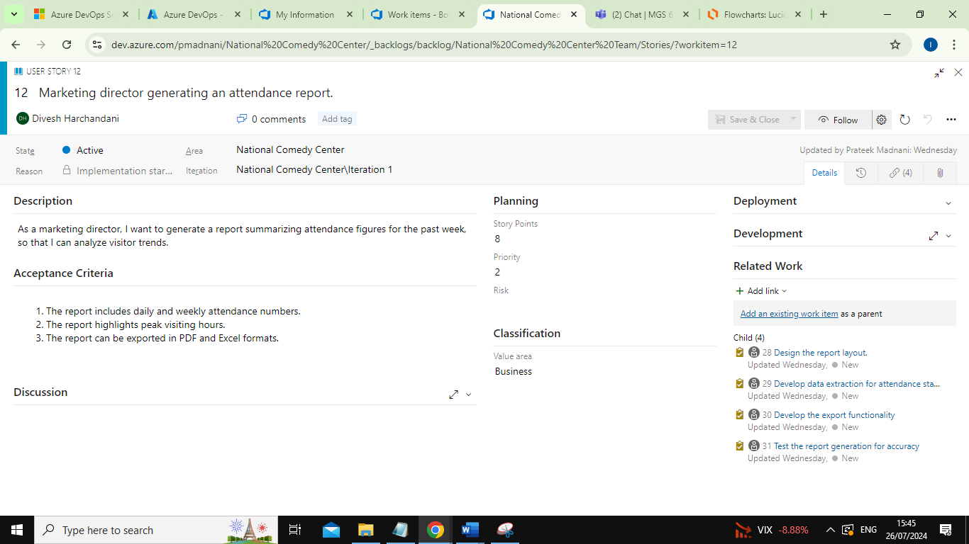

Tasks for User Story 4:

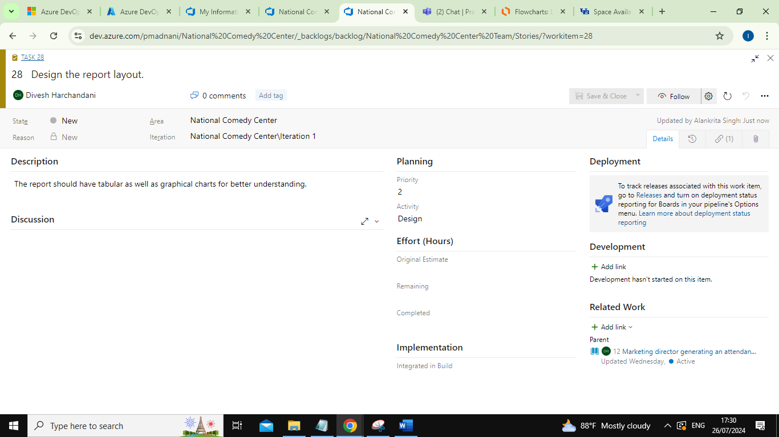

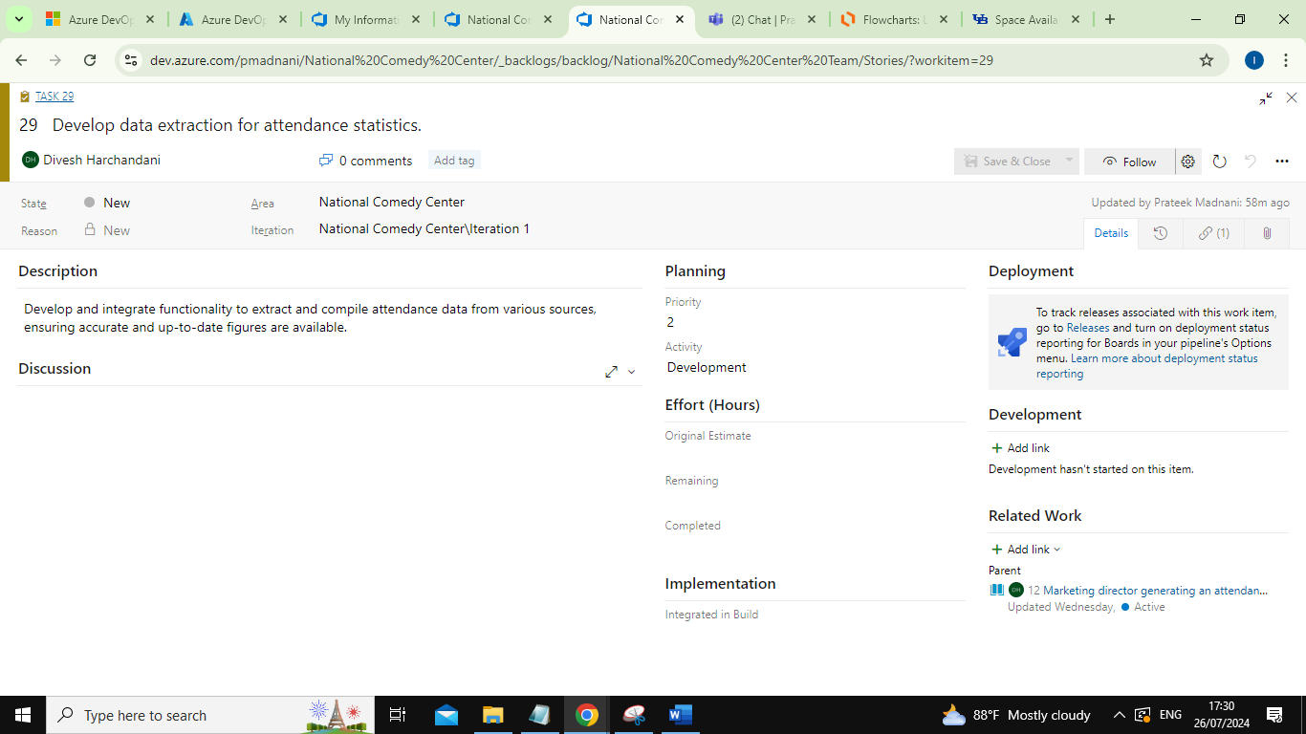

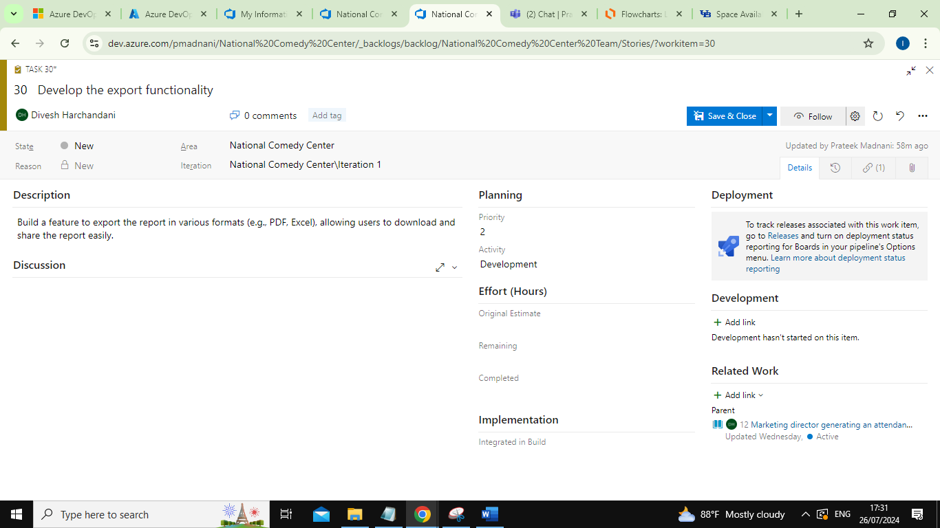

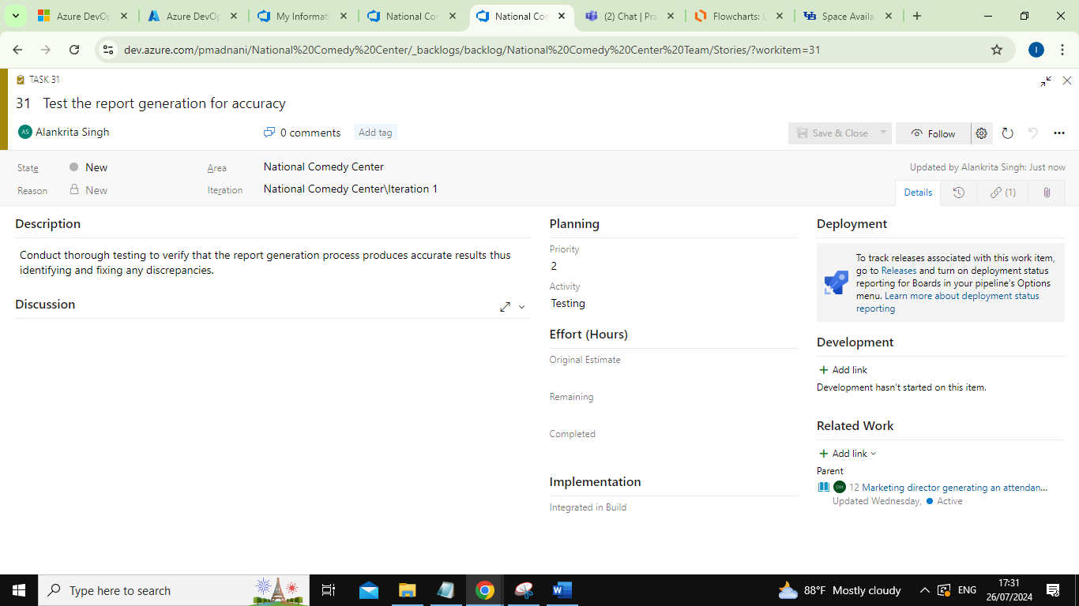

1. Marketing director determining the four most popular exhibits.

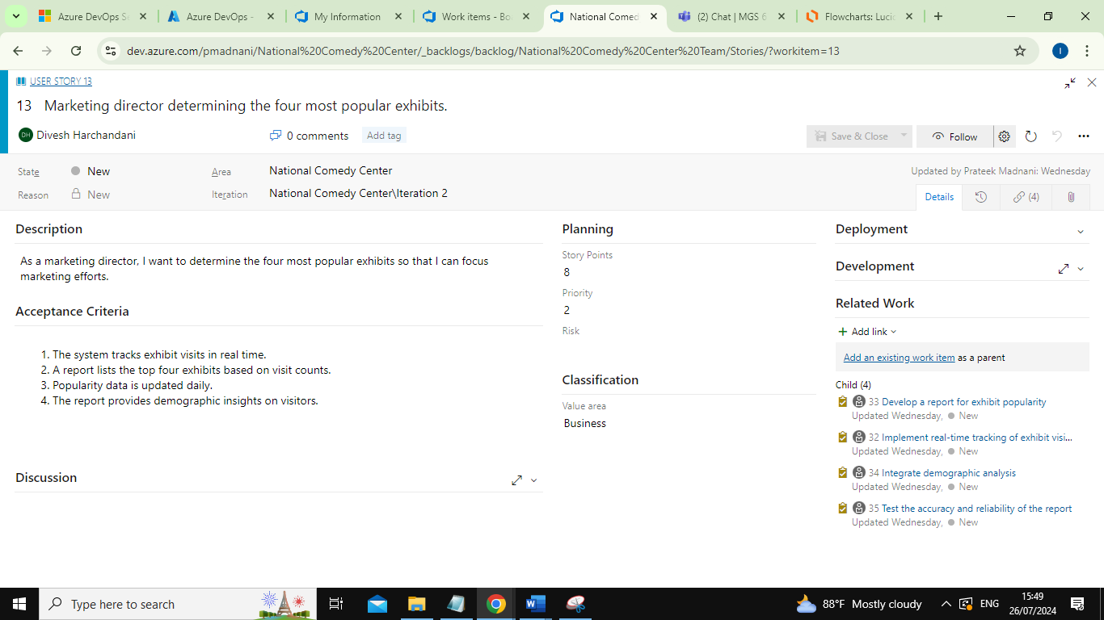

Tasks for User Story 5:

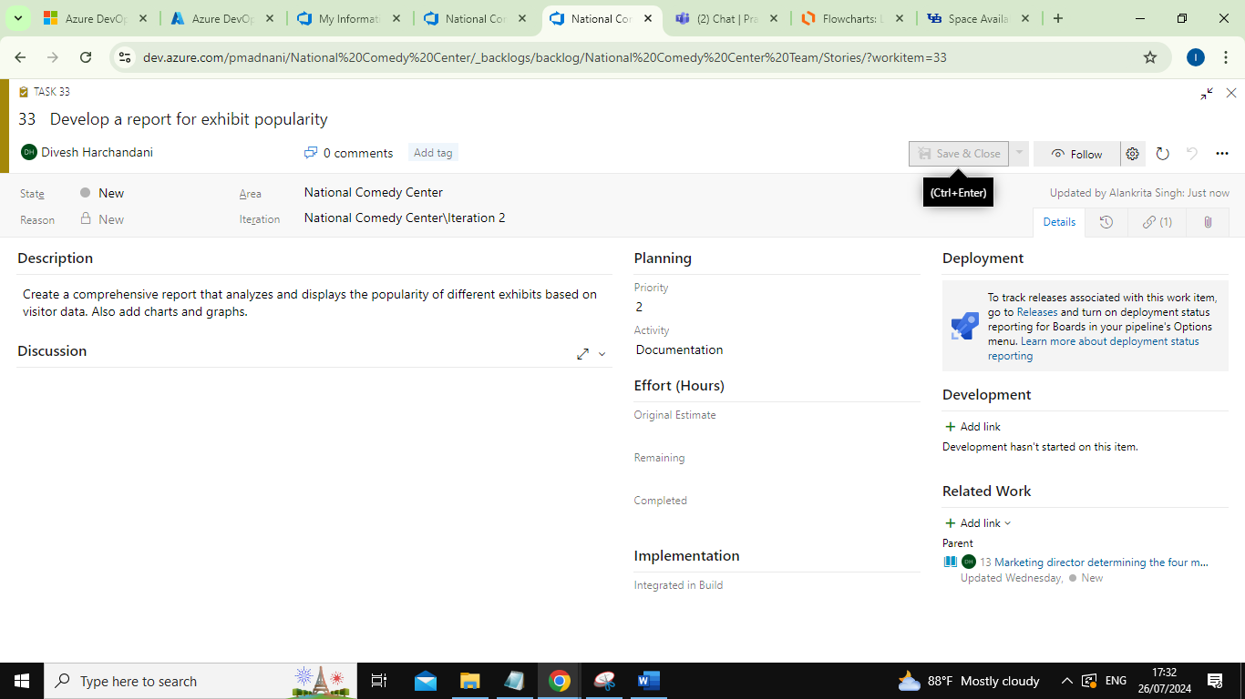

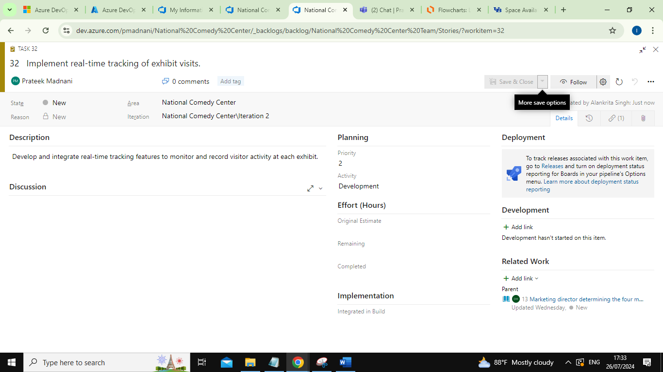

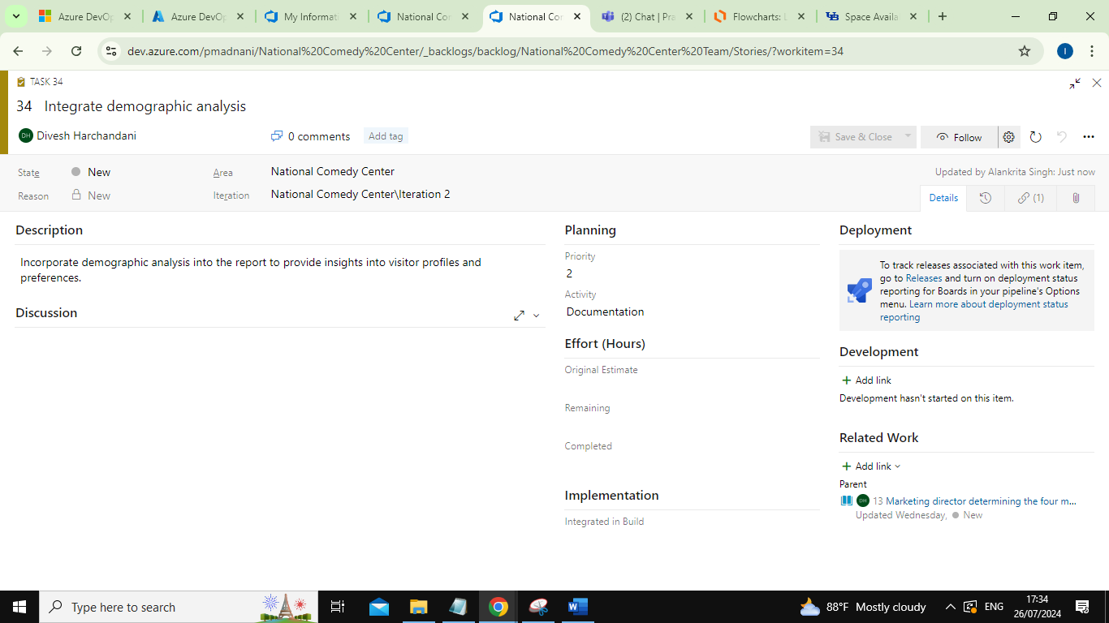

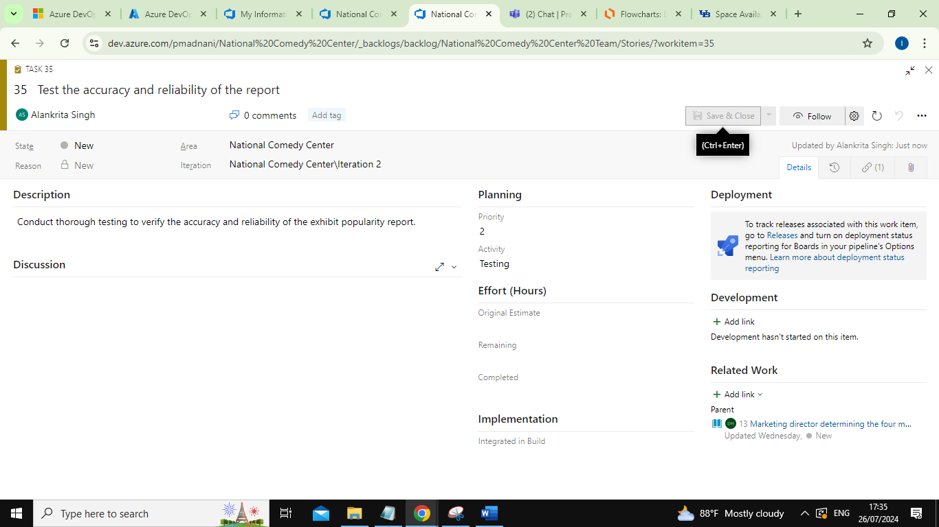

1. Marketing director sending a fund-raising email to all visitors from last week.

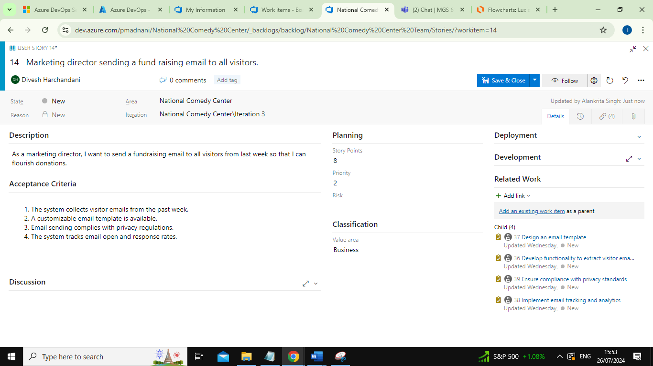

Tasks for User Story 6:

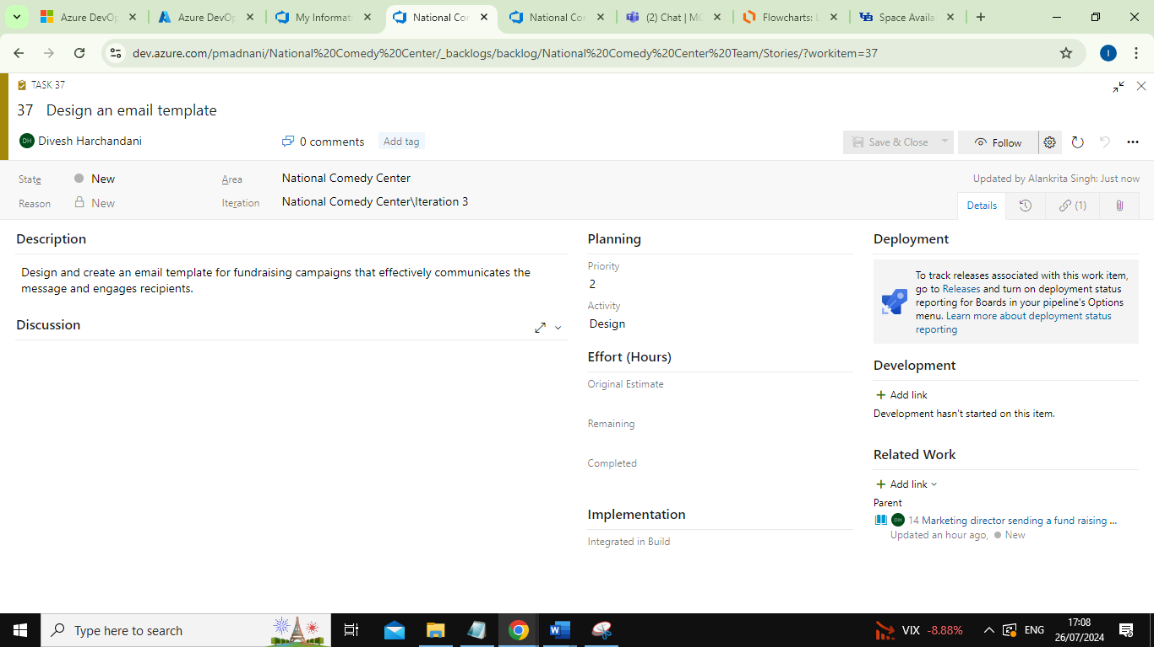

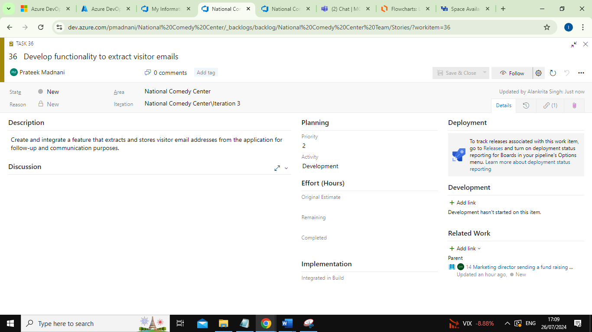

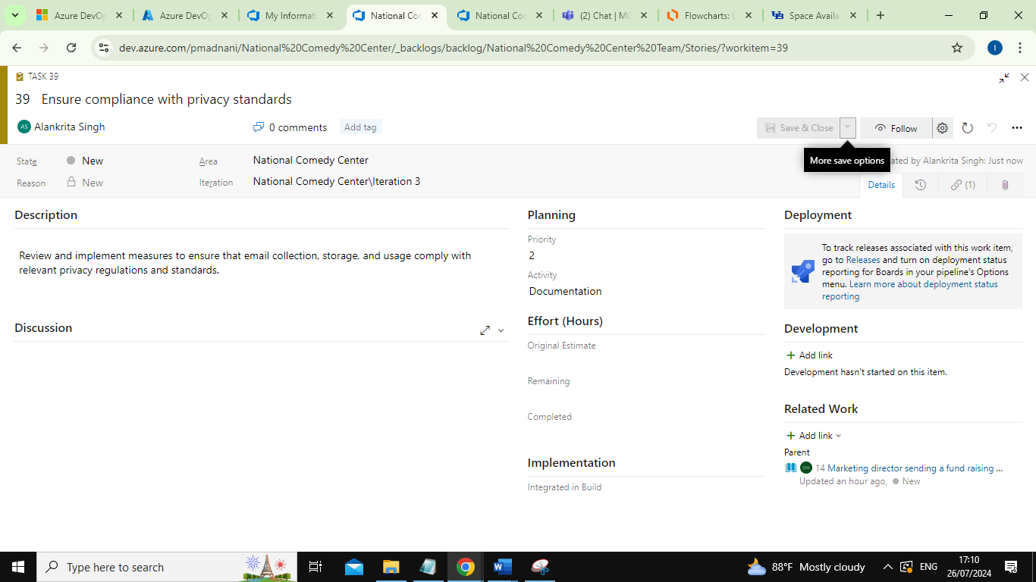

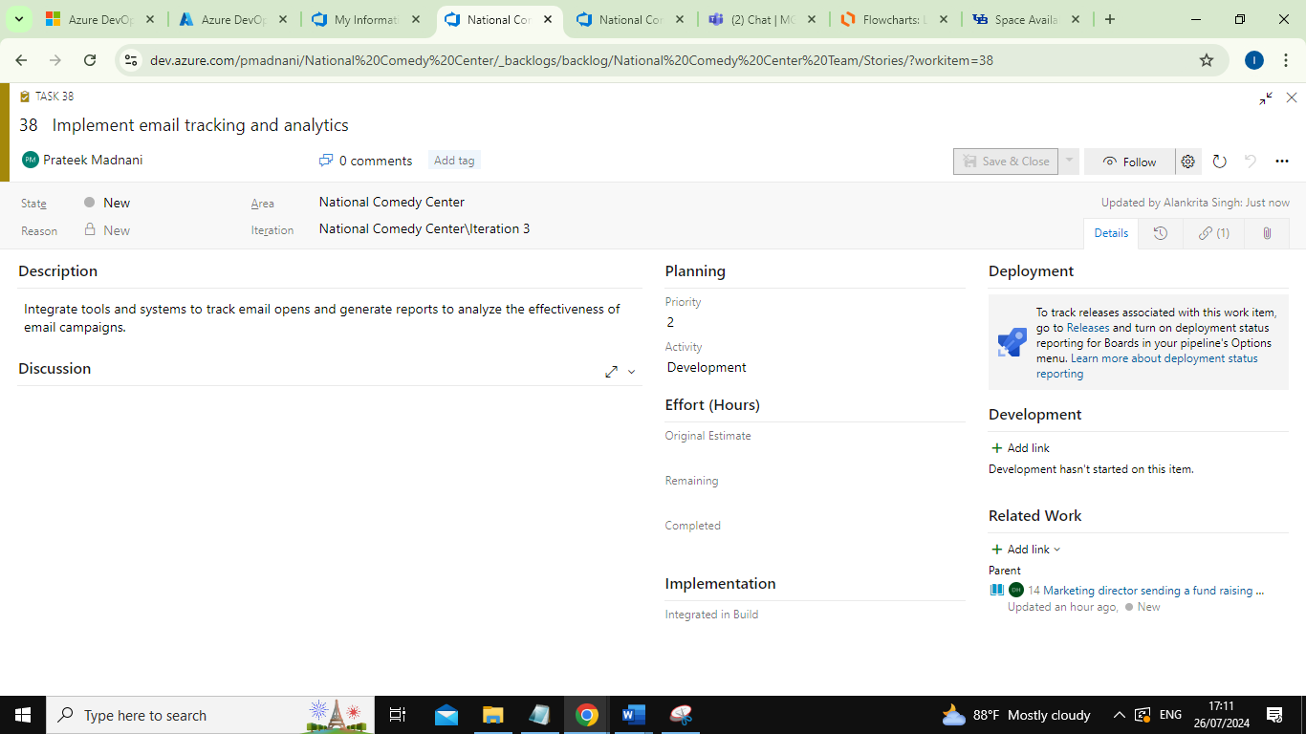

1. System administrator verifying the status of all the servers at the start of the day.

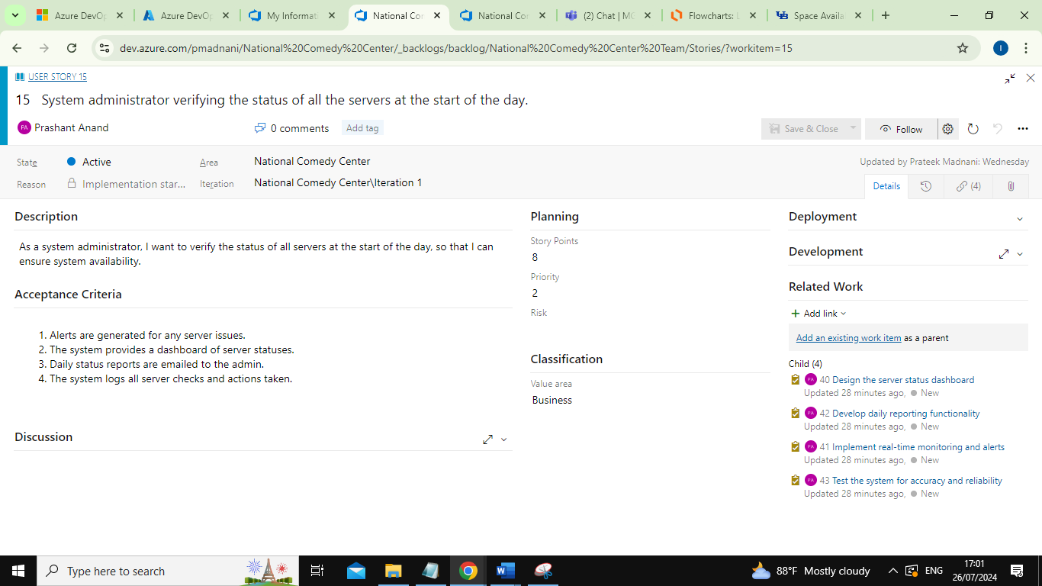

Tasks for User Story 7:

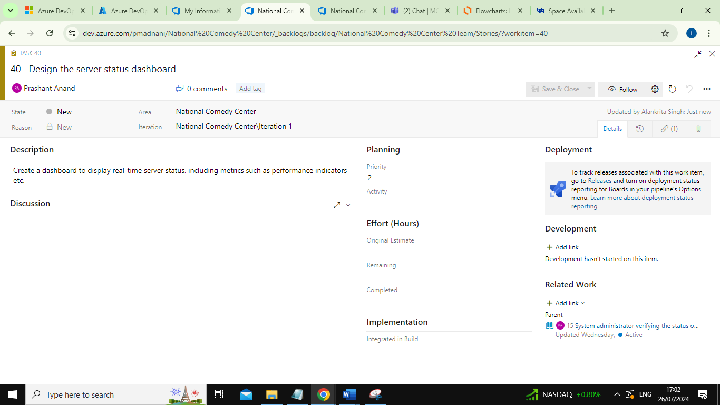

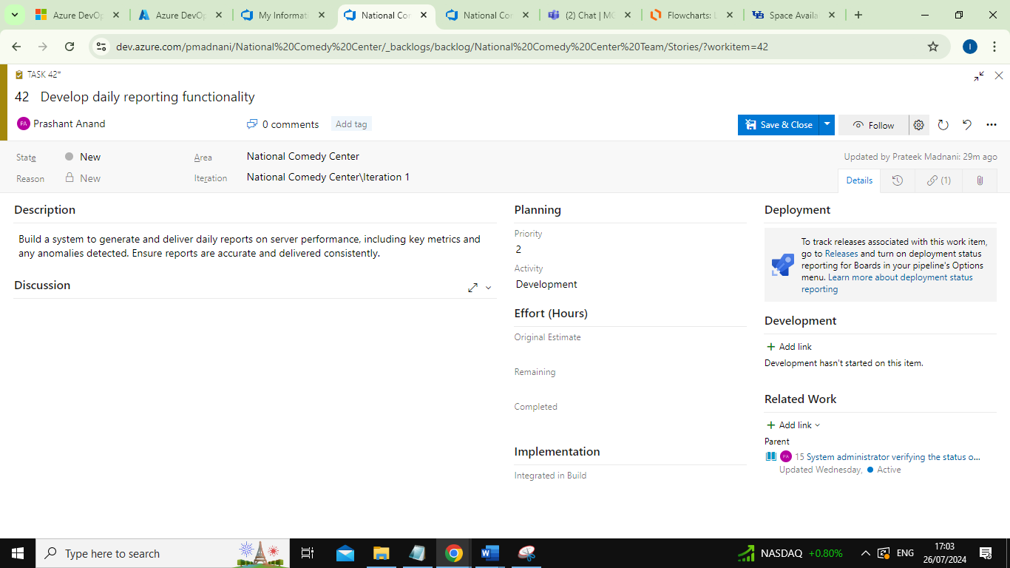

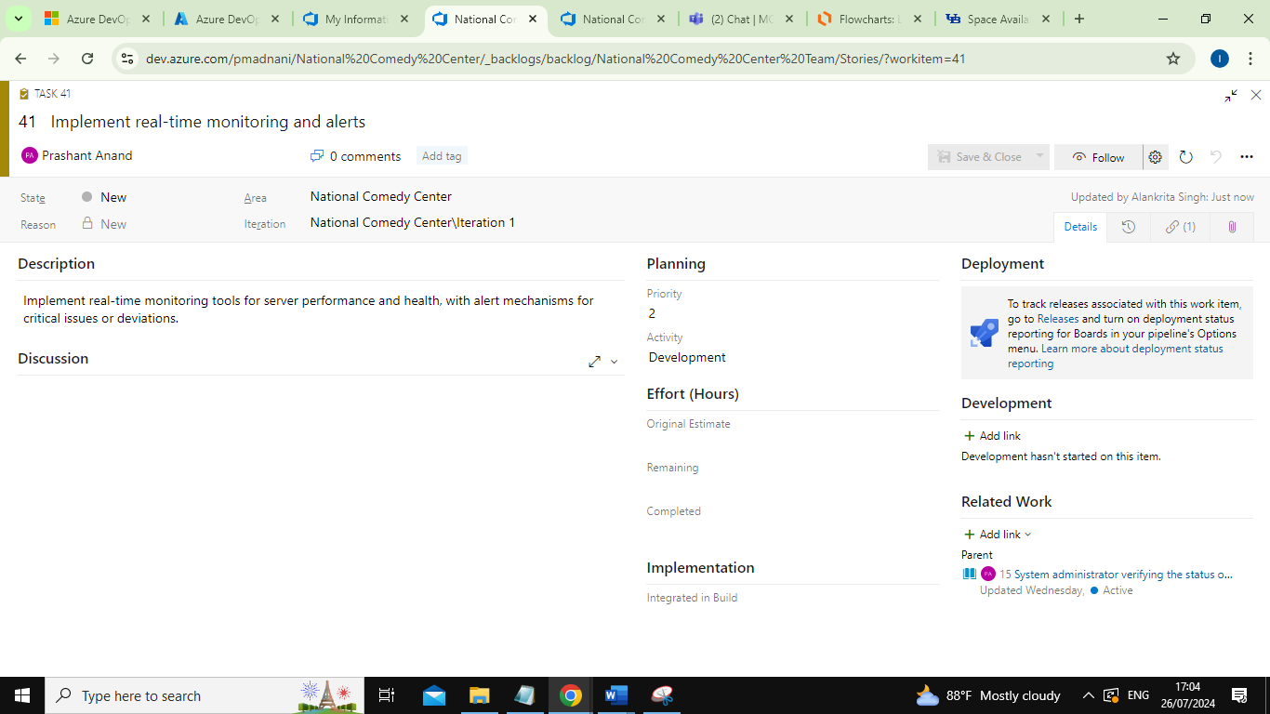

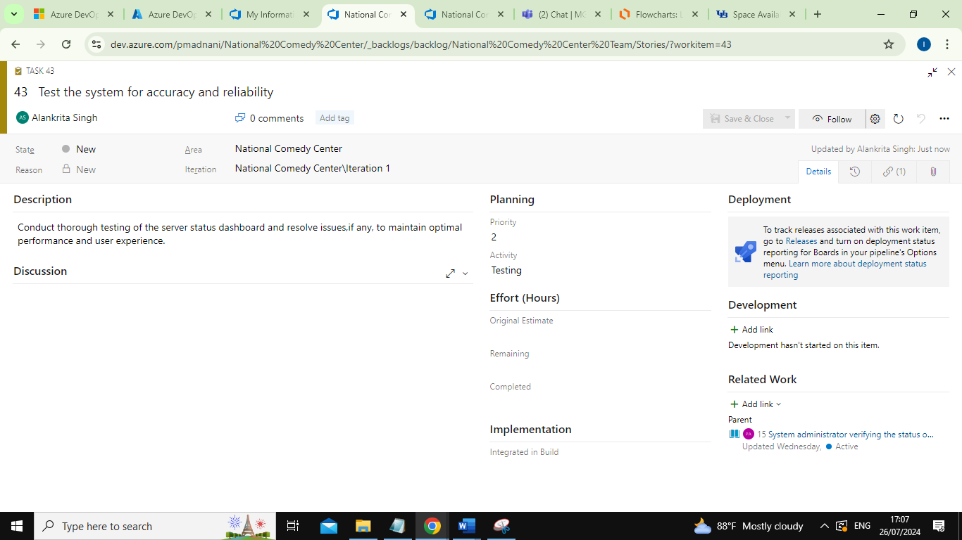

1. Database administrator backing up the comedian’s database.

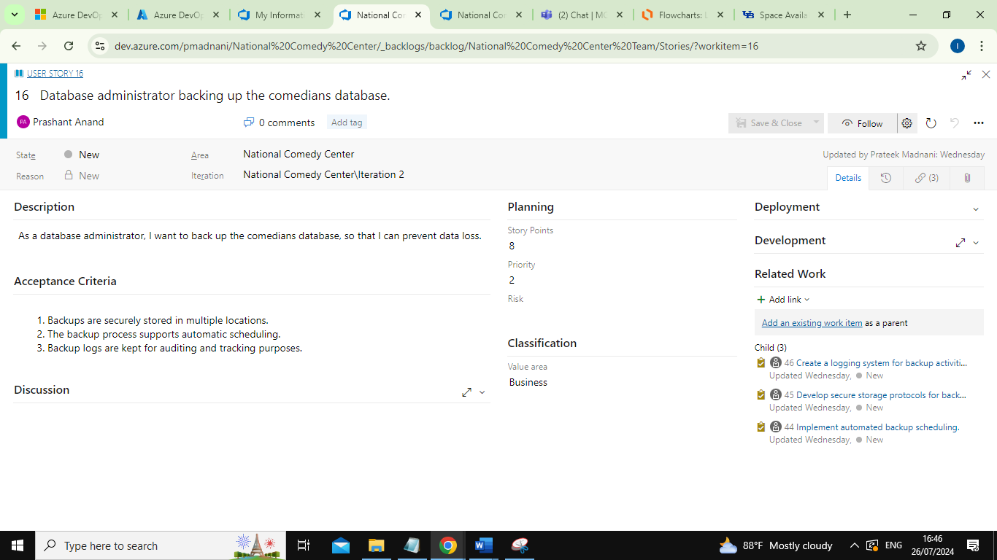

Tasks for User Story 8:

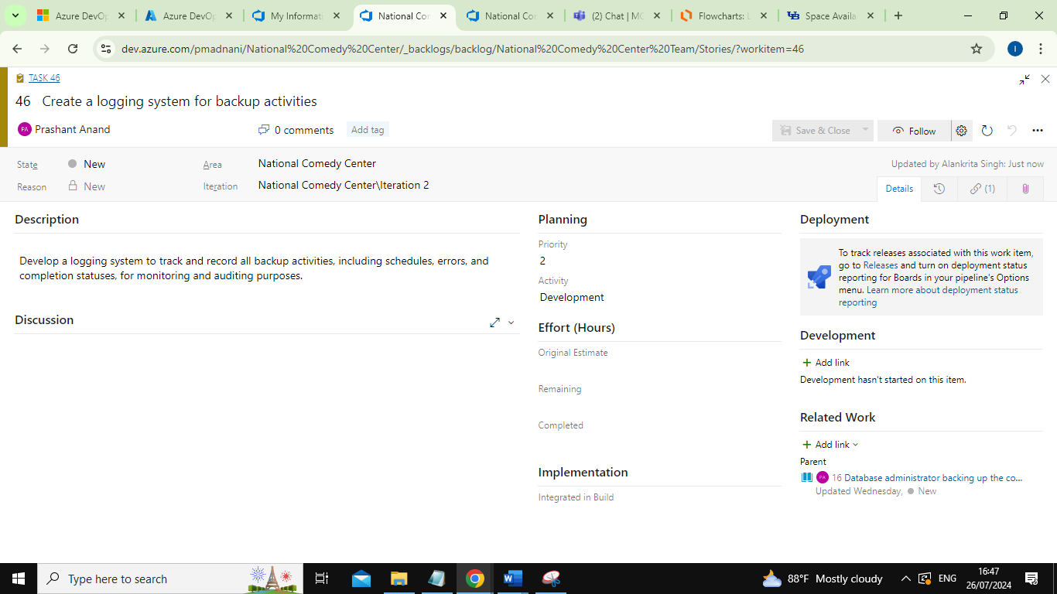

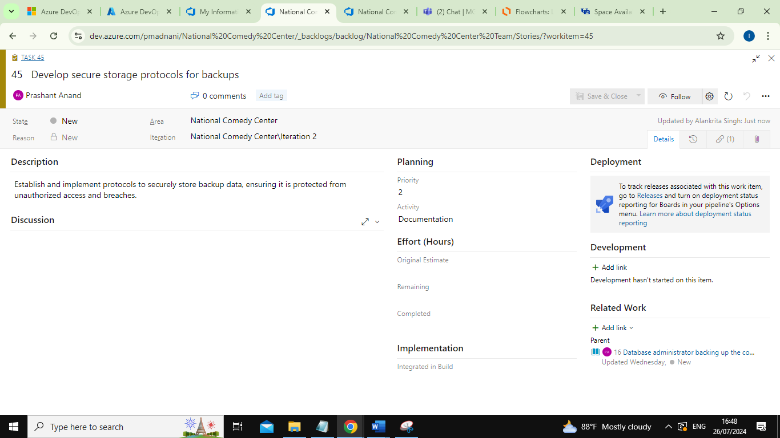

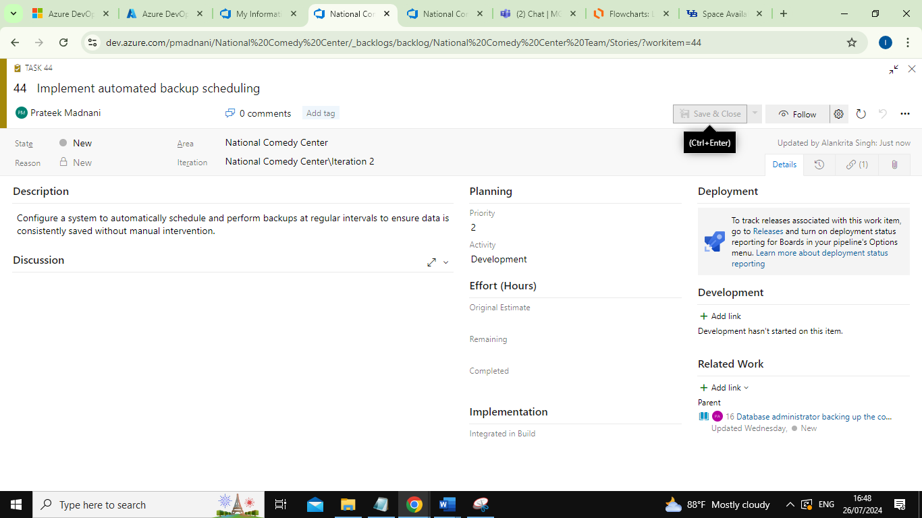

1. Human resources director adding a new cashier to the system.

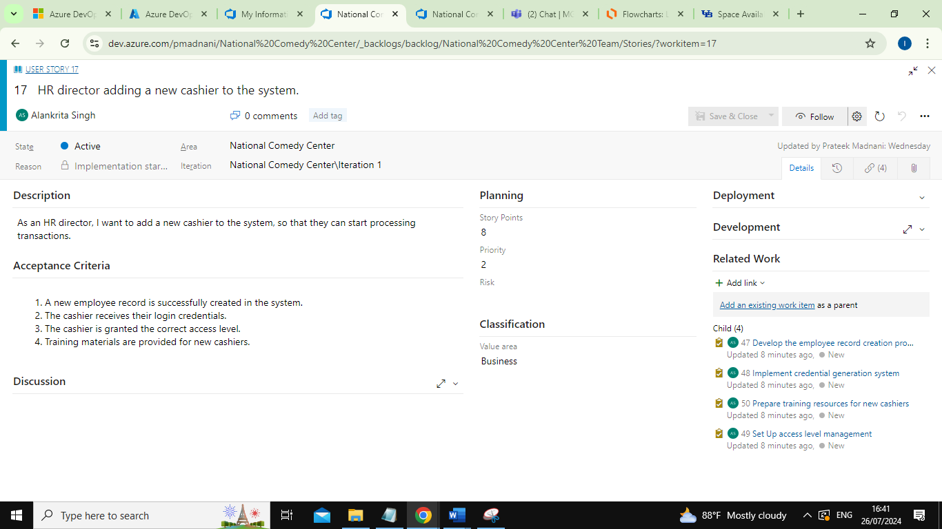

Tasks for User Story 9:

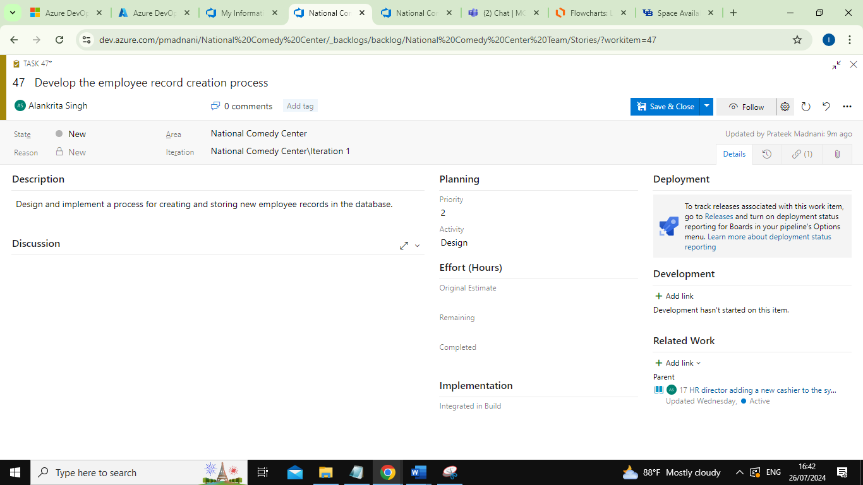

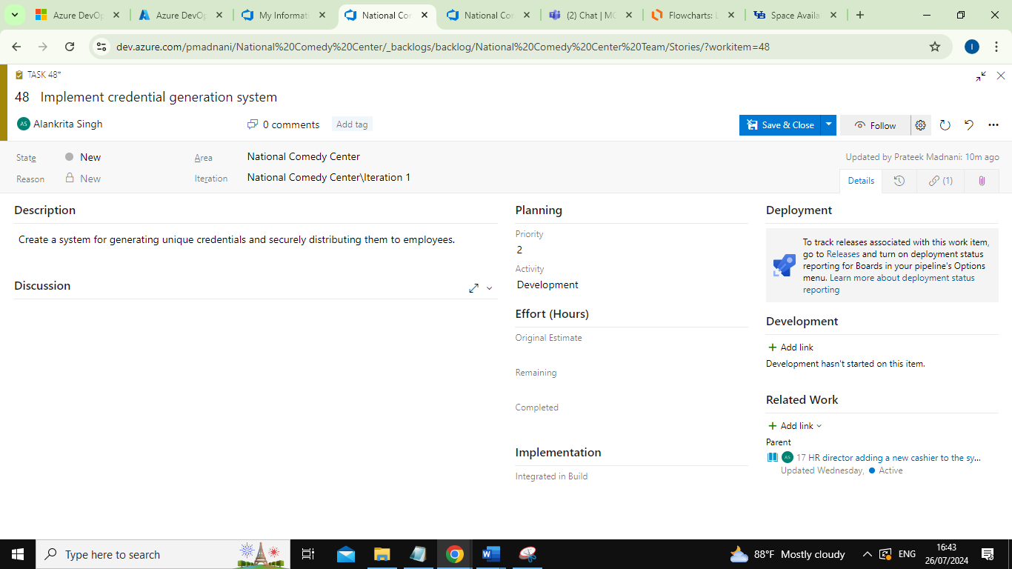

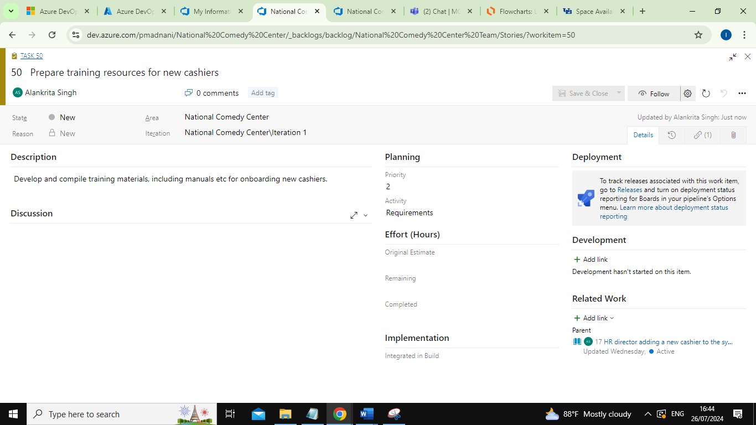

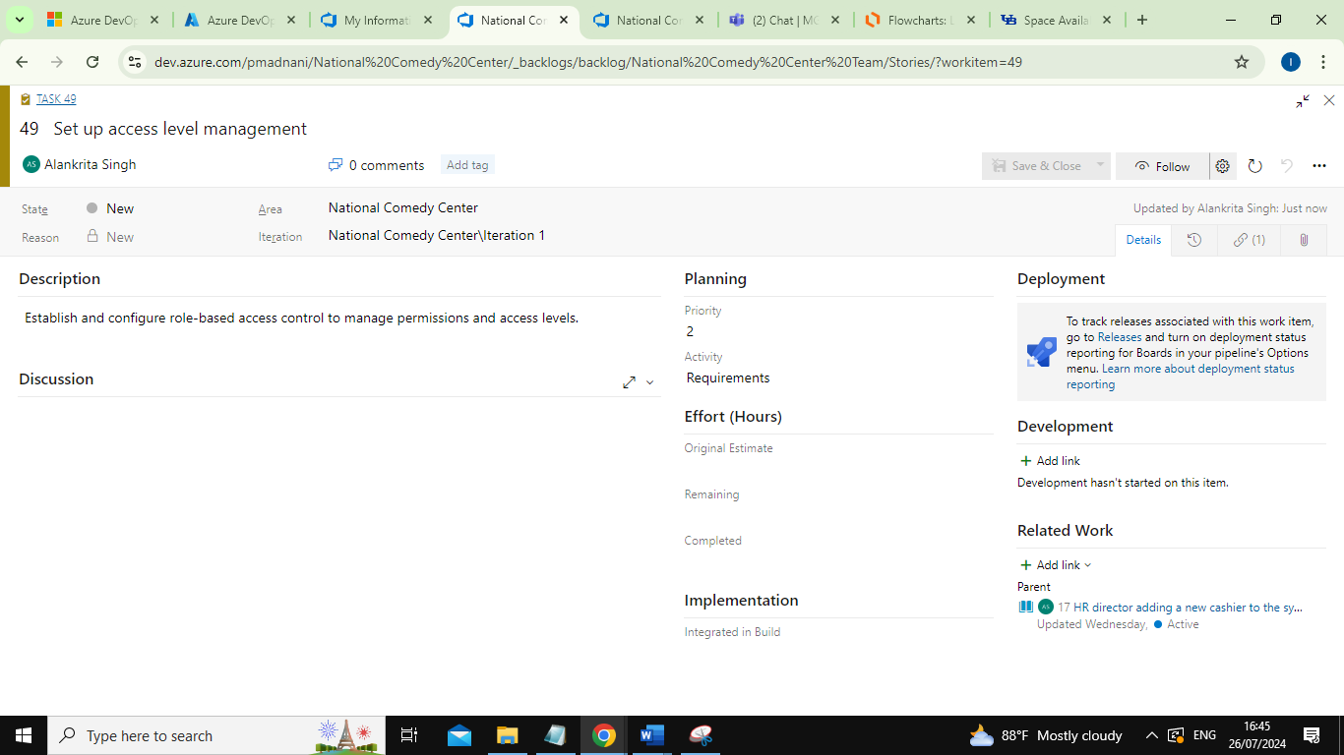

1. Human resources administrator discharging an employee for a fire able offense.

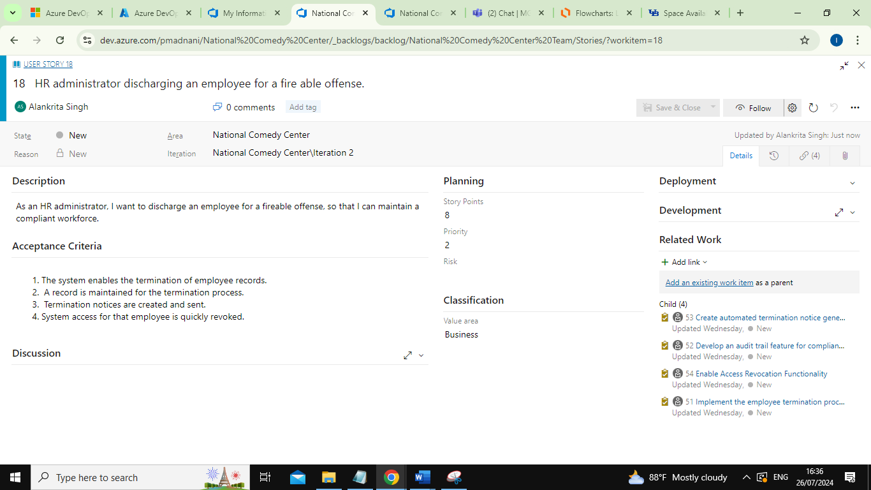

Tasks for User Story 10:

